Chapter 9 The Government and Fiscal Policy
Principles of Macroeconomics, Case/Fair, 8e

9.1 Government in the Economy
Multiple Choice

1)

Fiscal policy refers to

A)

the techniques used by a business firm to reduce its tax liability.

B)

the behavior of the nation's central bank, the Federal Reserve, regarding the nation's money supply.

C)

the spending and taxing policies used by the government to influence the economy.

D)

the government's ability to regulate a firm's behavior in the financial markets.

Answer:

C

Diff: 1

Skill: D

2)

Which of the following is NOT a category of fiscal policy?

A)

Government policies regarding the purchase of goods and services

B)

Government policies regarding taxation

C)

Government policies regarding money supply in the economy

D)

Government policies regarding transfer payments and welfare benefits

Answer:

C

Diff: 1

Skill: F

3)

What determines tax revenues?

A)

The income tax rate

B)

The income of households

C)

The money supply in the economy

D)

Both A and B are correct.

Answer:

D

Diff: 2

Skill: C

4)

Which of the following is INCORRECT regarding tax revenues?

A)

They increase during recessions.

B)

They change with changes in the tax rate.

C)

They are a revenue source in the government's budget.

D)

None of the above.

Answer:

A

Diff: 2

Skill: C

5)

During recessions, government spending usually

A)

decreases because unemployment payments decrease.

B)

increases because unemployment payments increase.

C)

decrease because unemployment payments increase.

D)

increases because unemployment payments decrease.

Answer:

B

Diff: 1

Skill: C

6)

Disposable income

A)

increases when net taxes increase.

B)

increases when income increases.

C)

decreases when saving increases.

D)

All of the above

Answer:

B

Diff: 1

Skill: C

7)

Bill's income is $1,000 and his net taxes are $350. His disposable income is

A)

$1,350.

B)

$650.

C)

-$350.

D)

$750.

Answer:

B

Diff: 1

Skill: A

8)

When the government sector is included in the income-expenditure model, the equation for aggregate income is

A)

Y = C + S - T.

B)

Y = C + I.

C)

Y = C + I + G.

D)

Y = C + S + I.

Answer:

C

Diff: 1

Skill: D

9)

The difference between what a government spends and what it collects in taxes in a year is

A)

net revenue.

B)

net taxes.

C)

the government budget deficit or surplus.

D)

the government debt.

Answer:

C

Diff: 1

Skill: D

10)

In 1998, the city of Canfield collected $500,000 in taxes and spent $450,000. In 1998, the city of Canfield had a

A)

budget surplus of $450,000.

B)

budget surplus of $50,000.

C)

budget deficit of $50,000.

D)

budget surplus of $5,000.

Answer:

B

Diff: 1

Skill: A

11)

In 1999, the city of Miketown collected $250,000 in taxes and spent $350,000. In 1999, the city of Miketown had a

A)

budget surplus of $100,000.

B)

budget surplus of 57%.

C)

budget deficit of $100,000.

D)

budget deficit of $200,000.

Answer:

C

Diff: 1

Skill: A

12)

When the government sector is included in the income-expenditure model, planned aggregate expenditure

A)

increases.

B)

decreases.

C)

stays the same.

D)

depends.

Answer:

A

Diff: 2

Skill: C

13)

After government is added to the income-expenditure model, the formula for the aggregate consumption function is

A)

C = a - b(Y - T).

B)

C = a - b(T - Y).

C)

C = a + b(Y + T).

D)

C = a + b(Y - T).

Answer:

D

Diff: 2

Skill: D

14)

The aggregate consumption function is C = 100 + .6Yd. If income is $1,000 and net taxes are $300, consumption equals

A)

800.

B)

520.

C)

580.

D)

700.

Answer:

B

Diff: 2

Skill: A

15)

The aggregate consumption function is C = 800 + .8Yd. If income is $2,000 and net taxes are $500, consumption equals

A)

2,000.

B)

1,500.

C)

2,150.

D)

2,050.

Answer:

A

Diff: 2

Skill: A

16)

The aggregate consumption function is C = 100 + .8Yd. If income is $600 and net taxes are zero, consumption equals

A)

zero.

B)

460.

C)

580.

D)

360.

Answer:

C

Diff: 2

Skill: A

17)

The aggregate consumption function is C = 1,000 + .9Yd. If income is $3,600 and net taxes are $600, consumption equals

A)

3,400.

B)

3,700.

C)

2,400.

D)

4,000.

Answer:

B

Diff: 2

Skill: A

18)

If output is less than planned aggregate expenditure, there will be

A)

an unplanned increase in inventories.

B)

an unplanned decrease in inventories.

C)

no change in inventories.

D)

a planned increase in inventories.

Answer:

B

Diff: 2

Skill: C

Refer to the information provided in Table 9.1 below to answer the questions that follow.

Table 9.1
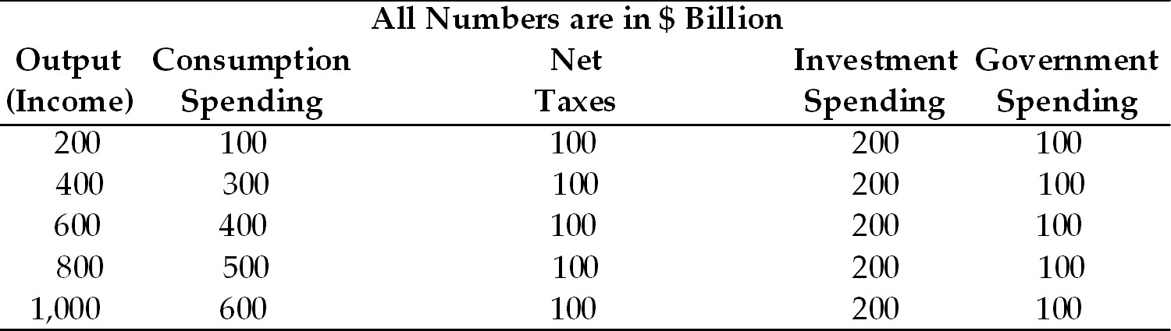

19)

Refer to Table 9.1. At an output level of $600 billion, the level of aggregate expenditure is

A)

$500 billion.

B)

$600 billion.

C)

$700 billion.

D)

$900 billion.

Answer:

C

Diff: 1

Skill: A

20)

Refer to Table 9.1. At an output level of $600 billion, there is an unplanned inventory change of

A)

positive $10 billion.

B)

zero.

C)

negative $100 billion.

D)

positive $100 billion.

Answer:

C

Diff: 2

Skill: A

21)

Refer to Table 9.1. At an output level of $1000 billion, the level of aggregate expenditure is

A)

$700 billion.

B)

$800 billion.

C)

$900 billion.

D)

$1,000 billion.

Answer:

C

Diff: 1

Skill: A

22)

Refer to Table 9.1. At an output level of $1000 billion, there is an unplanned inventory change of

A)

positive $100 billion.

B)

positive $10 billion.

C)

negative $100 billion.

D)

zero.

Answer:

A

Diff: 2

Skill: A

23)

Refer to Table 9.1. The equilibrium level of output is ________ billion.

A)

$600

B)

$700

C)

$800

D)

$1,000

Answer:

C

Diff: 1

Skill: A

24)

Refer to Table 9.1. At an output level of $400 billion, disposable income equals ________ billion.

A)

$400

B)

$300

C)

$200

D)

$100

Answer:

B

Diff: 1

Skill: A

25)

Refer to Table 9.1. At an output level of $1,000 billion, the value of saving

A)

cannot be determined from the given information.

B)

is $300 billion.

C)

is $200 billion.

D)

is $100 billion.

Answer:

B

Diff: 2

Skill: A

26)

Refer to Table 9.1. At the equilibrium level of income, leakages equal ________ billion.

A)

$0

B)

$100

C)

$200

D)

$300

Answer:

D

Diff: 3

Skill: A

27)

Refer to Table 9.1 At an output level of $600 billion, there is a tendency for output

A)

to fall.

B)

to increase.

C)

to remain constant.

D)

to either increase or decrease.

Answer:

B

Diff: 3

Skill: A

Refer to the information provided in Table 9.2 below to answer the questions that follow.

Table 9.2
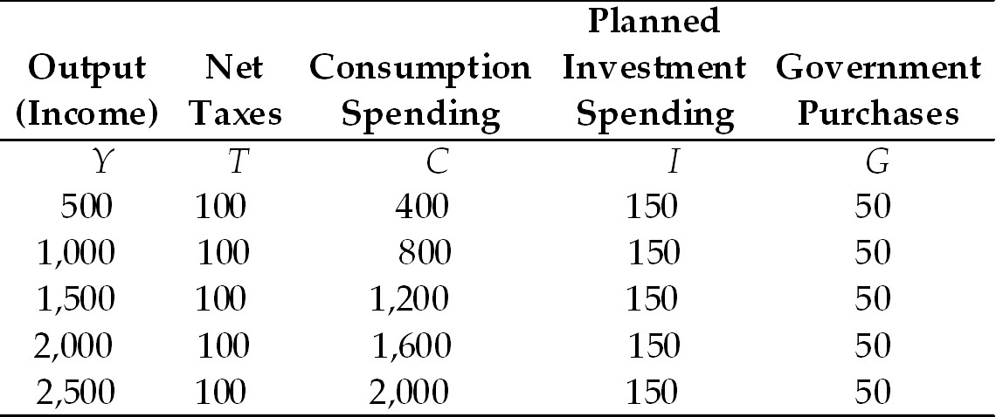

28)

Refer to Table 9.2. At an output level of $1,500 billion, the level of aggregate expenditure is ________ billion.

A)

$1,300

B)

$1,400

C)

$1,500

D)

$1,600

Answer:

B

Diff: 1

Skill: A

29)

Refer to Table 9.2. At an output level of $1,500 billion, there is an unplanned inventory

A)

decrease of $200 billion.

B)

change of $0.

C)

increase of $100 billion.

D)

increase of $150 billion.

Answer:

C

Diff: 2

Skill: A

30)

Refer to Table 9.2. At an output level of $2,500, the level of aggregate expenditure is ________ billion.

A)

$1,500

B)

$2,000

C)

$2,300

D)

$2,200

Answer:

D

Diff: 1

Skill: A

31)

Refer to Table 9.2. At an output level of $2,500, there is an unplanned inventory

A)

increase of $300 billion.

B)

decrease of $200 billion.

C)

change of $0.

D)

increase of $200 billion.

Answer:

A

Diff: 2

Skill: A

32)

Refer to Table 9.2. The equilibrium level of output is ________ billion.

A)

$1000

B)

$1,500

C)

$2,000

D)

$2,500

Answer:

A

Diff: 1

Skill: A

33)

Refer to Table 9.2. At an output level of $1,500, disposable income

A)

is $1,000.

B)

is $1,200.

C)

is $1,400.

D)

cannot be determined from this information.

Answer:

C

Diff: 1

Skill: A

34)

Refer to Table 9.2. At an output level of $2,500, the level for saving

A)

is $300.

B)

is $400.

C)

is $500.

D)

cannot be determined from this information.

Answer:

B

Diff: 2

Skill: A

35)

Refer to Table 9.2 At the equilibrium level of income, leakages equal ________ billion.

A)

$0

B)

$300

C)

$500

D)

$200

Answer:

D

Diff: 3

Skill: A

36)

Refer to Table 9.2. At an output level of $2,500, there is a tendency for output

A)

to increase.

B)

to remain constant.

C)

to either increase or decrease.

D)

to fall.

Answer:

D

Diff: 2

Skill: A

The Italian economy can be characterized by Equation 9.1.

EQUATION 9.1:

C = 200 + .75Yd
G = 500
T = 200
I = 200

37)

Refer to Equation 9.1. The equilibrium level of output for the Italian economy is

A)

$2,533.3.

B)

$3,000.

C)

$2,678.9.

D)

$3,500.

Answer:

B

Diff: 2

Skill: A

38)

Refer to Equation 9.1. At the equilibrium level of output in Italy, consumption equals

A)

$2,300.

B)

$2,500.

C)

$1,833.3.

D)

$2,010.2

Answer:

A

Diff: 2

Skill: A

39)

Refer to Equation 9.1. At the equilibrium level of output in Italy, saving equals

A)

$450.

B)

$400.

C)

$550.

D)

$500.

Answer:

D

Diff: 3

Skill: A

40)

Refer to Equation 9.1. At the equilibrium level of output in Italy, leakages equal

A)

$650.

B)

$600.

C)

$750.

D)

$700.

Answer:

D

Diff: 3

Skill: A

The Canadian economy can be characterized by Equation 9.2.

EQUATION 9.2:

C = 500 + .5Yd
Taxes = 600
Equilibrium Output = $4,000

41)

Refer to Equation 9.2. At equilibrium, the sum of investment and government purchases in Canada is

A)

$1,800.

B)

$1,500.

C)

$1,750.

D)

cannot be determined from the given information.

Answer:

A

Diff: 3

Skill: A

42)

Refer to Equation 9.2. At equilibrium, government purchases in Canada is

A)

$1,500.

B)

$1,000.

C)

$1,250.

D)

Cannot be determined from the given information.

Answer:

D

Diff: 3

Skill: A

43)

Refer to Equation 9.2. At equilibrium, saving in Canada equals

A)

$1,200.

B)

$1,600.

C)

$1,350.

D)

$1,250.

Answer:

A

Diff: 3

Skill: A

44)

Refer to Equation 9.2. At equilibrium leakages in Canada equal

A)

$1,750.

B)

$1,800.

C)

$2,100.

D)

$1,700.

Answer:

B

Diff: 3

Skill: A

45)

Assuming there is no foreign trade in the economy, the economy is in equilibrium when

A)

S + T = C + I.

B)

I + G = S + T.

C)

IT = S + G.

D)

G + T = S + I.

Answer:

B

Diff: 1

Skill: F

46)

Assuming there is no foreign trade in the economy, equilibrium is achieved when government purchases equal

A)

saving minus net taxes minus consumption.

B)

saving plus net taxes minus investment.

C)

net taxes plus investment minus saving.

D)

net taxes minus investment minus saving.

Answer:

B

Diff: 1

Skill: F

Refer to the information provided in Figure 9.1 below to answer the questions that follow.

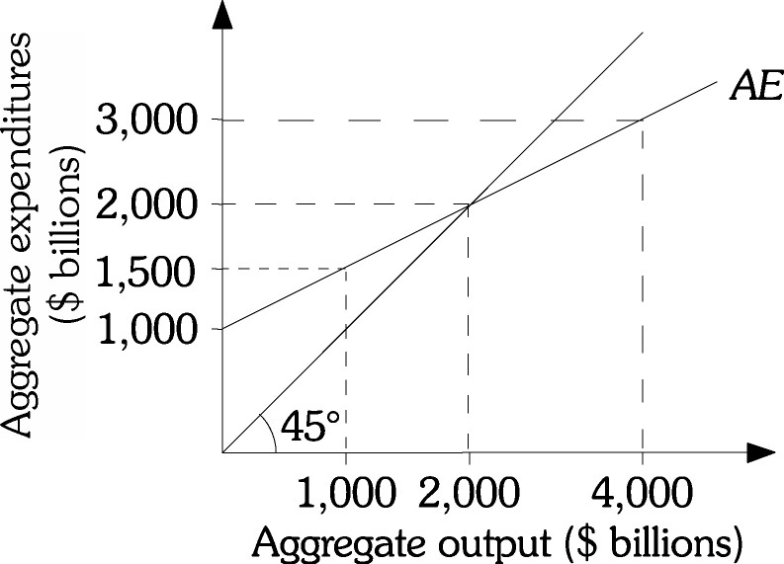

Figure 9.1

47)

Refer to Figure 9.1. The equilibrium level of aggregate expenditure is $________ billion.

A)

3,000

B)

2,000

C)

4,000

D)

1,500

Answer:

B

Diff: 1

Skill: A

48)

Refer to Figure 9.1. The MPC in this economy is

A)

0.4.

B)

0.6.

C)

0.5.

D)

Cannot be determined from the given information.

Answer:

C

Diff: 2

Skill: A

49)

Refer to Figure 9.1. At equilibrium, injections

A)

can be greater than $1,000 billion.

B)

equal $1,500 billion.

C)

equal leakages.

D)

equal $2,000 billion.

Answer:

C

Diff: 3

Skill: A

50)

Refer to Figure 9.1. At equilibrium, the part of consumption that is dependent on income equals $________ billion.

A)

$1,500

B)

$1,000

C)

$2,000

D)

Cannot be determined from the given information.

Answer:

B

Diff: 2

Skill: A

51)

Refer to Figure 9.1. Suppose that the consumption function is C = 400 + 0.5Yd and taxes are $200 billion, at equilibrium the value of injections are

A)

$700 billion.

B)

$500 billion.

C)

$650 billion.

D)

$350 billion.

Answer:

A

Diff: 3

Skill: A

52)

Refer to Figure 9.1. Suppose that the consumption function is C = 400 + 0.5Yd and taxes are $200 billion, at equilibrium the value of autonomous consumption is

A)

$400 billion.

B)

$300 billion.

C)

$100 billion.

D)

$200 billion.

Answer:

B

Diff: 2

Skill: A

53)

Refer to Figure 9.1. Suppose that the consumption function is C = 400 + 0.5Yd and taxes are $200 billion, at equilibrium, what is the value of consumption?

A)

$1,350

B)

$2,000

C)

$1,300

D)

$1,150

Answer:

C

Diff: 2

Skill: A

54)

If planned injections exceed leakages, output will

A)

decrease.

B)

increase.

C)

remain constant.

D)

either increase or decrease.

Answer:

B

Diff: 2

Skill: C

55)

For the economy to be in equilibrium,

A)

government purchases must equal tax revenue and saving must equal investment.

B)

government purchases must equal the sum of tax revenue, saving and investment.

C)

government purchases plus investment must equal saving plus tax revenue.

D)

investment plus tax revenue must equal government purchases plus saving.

Answer:

C

Diff: 1

Skill: F

True/False

1)

The economy is in equilibrium when aggregate output equals consumption spending.

Answer:

True
False

Diff: 1

Skill: D

2)

For the economy to be in equilibrium, the following condition must be satisfied: G + I = S + T.

Answer:

True
False

Diff: 1

Skill: D

3)

When investment is greater than planned investment, output grows.

Answer:

True
False

Diff: 2

Skill: C

4)

Disposable income is income less net taxes.

Answer:

True
False

Diff: 1

Skill: D

9.2 Fiscal Policy at Work: Multiplier Effect
Multiple Choice

1)

If the government wants to reduce unemployment, government purchases should be ________ and/or taxes should be ________.

A)

increased; increased

B)

decreased; decreased

C)

decreased; increased

D)

increased; decreased

Answer:

D

Diff: 1

Skill: C

2)

The President of Vulcan hires you as an economic consultant. He is concerned that the output level in Vulcan is too high and that this will cause prices to rise. He feels that it is necessary to reduce output by $10 billion. He tells you that the MPC in Vulcan is .6. Which of the following would be the best advice to give to the Vulcan president?

A)

Reduce government purchases in Vulcan by $4 billion.

B)

Increase taxes in Vulcan by $10 billion.

C)

Reduce government purchases in Vulcan by $10 billion.

D)

Increase taxes in Vulcan by $2.5 billion.

Answer:

A

Diff: 2

Skill: A

3)

The leader of Atlantis hires you as an economic consultant. He is concerned that the output level in Atlantis is too low and that this will cause prices to fall. He feels that it is necessary to increase output by $200 billion. He tells you that the MPC in Atlantis is .8. Which of the following would be the best advice to give to the Atlantis president?

A)

Reduce government spending in Atlantis by $100 billion.

B)

Decease taxes in Atlantis by $50 billion.

C)

Increase government spending in Atlantis by $200 billion.

D)

Increase government spending in Atlantis by $100 billion.

Answer:

B

Diff: 2

Skill: A

Refer to the information provided in Table 9.3 below to answer the questions that follow.

Table 9.3
All Numbers are in $ Million
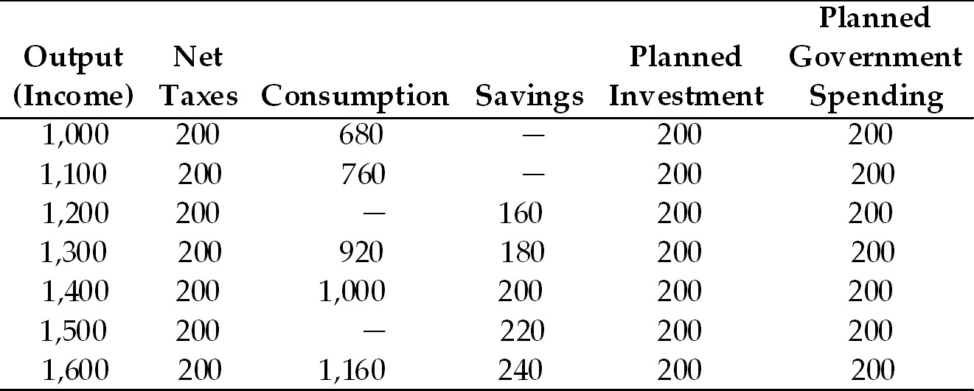

4)

Refer to Table 9.3. Assuming constant MPC, at income of $1,200 million, consumption is $________ million, and at income of $1,500 million, consumption is $________ million.

A)

800; 1,100

B)

790; 1,150

C)

840; 1,080

D)

900; 1,150

Answer:

C

Diff: 1

Skill: A

5)

Refer to Table 9.3. Assuming constant MPC, at income of $1,000 million, saving is $________ million, at income of $1,100 million, saving is $________ million.

A)

100; 110

B)

120; 140

C)

130; 150

D)

140; 150

Answer:

B

Diff: 1

Skill: A

6)

Refer to Table 9.3. The MPC in this economy is ________ and the MPS is ________.

A)

0.5; 0.5

B)

0.7; 0.5

C)

0.9; 0.1

D)

0.8; 0.2

Answer:

D

Diff: 2

Skill: A

7)

Refer to Table 9.3. The equilibrium level of aggregate output is $________ million.

A)

1,200

B)

1,300

C)

1,400

D)

1,500

Answer:

C

Diff: 1

Skill: A

8)

Refer to Table 9.3. Which of the following variables is NOT considered autonomous?

A)

Saving

B)

Planned investment

C)

Planned government spending

D)

None of the above

Answer:

A

Diff: 1

Skill: A

9)

Refer to Table 9.3. Suppose the economy is in equilibrium and the government increases spending by $50 million, the new equilibrium output is $________ million

A)

1,650

B)

1,450

C)

1,750

D)

1,350

Answer:

A

Diff: 2

Skill: A

10)

Refer to Table 9.3. Suppose the economy is in equilibrium and the government raises taxes from $100 million to $120 million, equilibrium output will ________ by $________ million.

A)

decrease; 20

B)

increase; 20

C)

decrease; 80

D)

increase; 80

Answer:

C

Diff: 2

Skill: A

Refer to the information provided in Table 9.4 below to answer the questions that follow.

Table 9.4
All Figures in Billions of Dollars
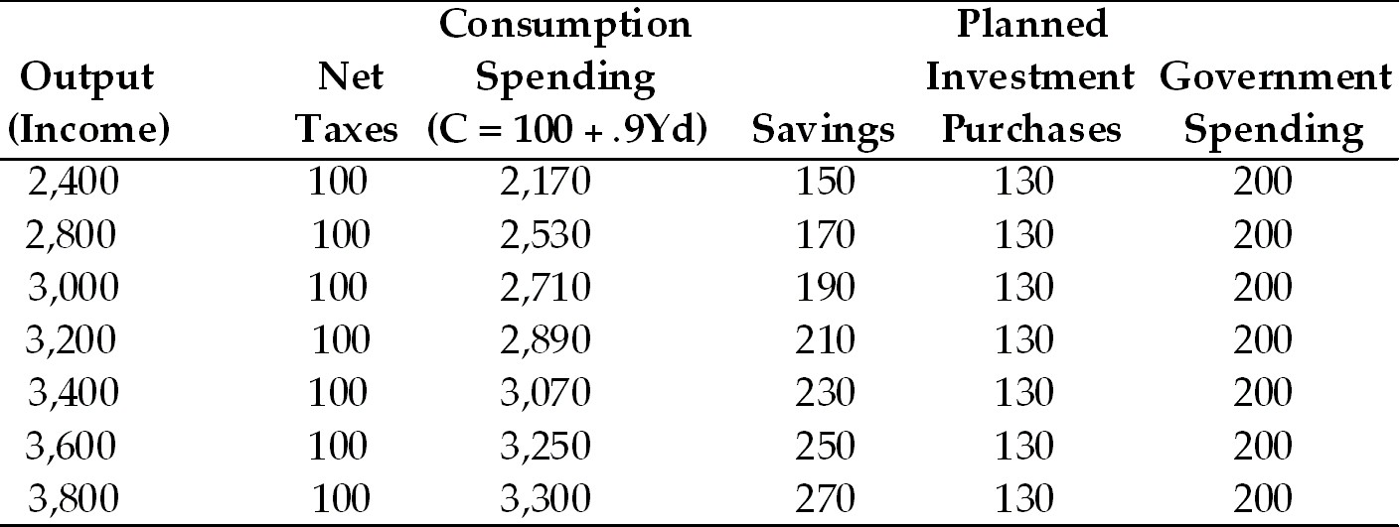

11)

Refer to Table 9.4. The equilibrium level of income is

A)

$3400 billion.

B)

$3,800 billion.

C)

$2,000 billion.

D)

$3,600 billion.

Answer:

A

Diff: 1

Skill: A

12)

Refer to Table 9.4. The MPS

A)

is .8.

B)

is .1.

C)

is .2

D)

cannot be determined from the available information.

Answer:

B

Diff: 2

Skill: A

13)

Refer to Table 9.4. The value of the government spending multiplier

A)

is 10.

B)

is .9.

C)

is 5.

D)

Cannot be determined from the available information

Answer:

A

Diff: 2

Skill: A

14)

Refer to Table 9.4. The economy is at the equilibrium level of output. If government spending increases to $400 billion, the new equilibrium level of output is

A)

$5,400 billion.

B)

$2,100 billion.

C)

$6,040 billion.

D)

$6,600 billion.

Answer:

A

Diff: 2

Skill: A

15)

Refer to Table 9.4. The economy is at the equilibrium level of output. If government spending decreases by $100 billion, the new equilibrium level of output is

A)

$3,100 billion.

B)

$2,400 billion.

C)

$1,450 billion.

D)

$1,550 billion.

Answer:

B

Diff: 2

Skill: A

16)

Refer to Table 9.4. If taxes are reduced from $100 billion to $50 billion, the new equilibrium level of output is

A)

$4,050 billion.

B)

$1,600 billion.

C)

$3,850 billion.

D)

$2,100 billion.

Answer:

C

Diff: 2

Skill: A

17)

Refer to Table 9.4. If taxes are reduced from $100 billion to $50 billion and government spending is reduced from $200 billion to $150 billion, the new equilibrium level of income

A)

is $3,350 billion.

B)

is $3,550 billion.

C)

is $1,600 billion.

D)

cannot be determined from this information.

Answer:

A

Diff: 2

Skill: A

18)

The government purchases multiplier is

A)

the difference between the old equilibrium level of output and the new equilibrium level of output.

B)

the ratio of the change in government purchases to the change in the equilibrium level of output.

C)

the ratio of the change in the equilibrium level of output to a change in government purchases.

D)

the difference between the new and old levels of government purchases.

Answer:

C

Diff: 1

Skill: D

19)

The formula for the government spending multiplier is

A)

1/(1 + MPC).

B)

1/MPS.

C)

1/MPC.

D)

1/(1 + MPS).

Answer:

B

Diff: 1

Skill: D

20)

If the MPS is .2, the government spending multiplier is

A)

4.

B)

1.11.

C)

9.

D)

5.

Answer:

D

Diff: 1

Skill: F

21)

If the MPS is .1, the government spending multiplier is

A)

10.

B)

1.11.

C)

5.

D)

2.

Answer:

A

Diff: 1

Skill: F

22)

If the MPC is .6, the government spending multiplier is

A)

1.10.

B)

2.5.

C)

1.5.

D)

8.5.

Answer:

B

Diff: 1

Skill: F

23)

If the MPC is .5, the tax multiplier is

A)

-2.5.

B)

-2.

C)

-1.

D)

-1.666.

Answer:

C

Diff: 1

Skill: F

24)

If the government spending multiplier is 5 and government purchases increase by $100 billion, output will increase by

A)

$100 billion.

B)

$400 billion.

C)

$1,600 billion.

D)

$500 billion.

Answer:

D

Diff: 2

Skill: A

25)

If the government spending multiplier is 4 and government spending decreases by $50 billion, output will ________ by $________ billion.

A)

increase; 200

B)

decrease; 200

C)

decrease; 50

D)

decrease; 100

Answer:

B

Diff: 2

Skill: A

The economy of Bananaland can be characterized by Equation 9.3.

EQUATION 9.3:

C = 2,000 + .75Yd
T = 200
G = 400
I = 500

26)

Refer to Equation 9.3. The equilibrium level of income in Bananaland is

A)

4,800.

B)

11,000.

C)

10,000.

D)

5,600.

Answer:

B

Diff: 2

Skill: A

27)

Refer to Equation 9.3. If government spending in Bananaland increases by $100, equilibrium output increases by

A)

$100.

B)

$200.

C)

$400.

D)

$800.

Answer:

C

Diff: 2

Skill: A

Refer to the information provided in Figure 9.3 below to answer the questions that follow.

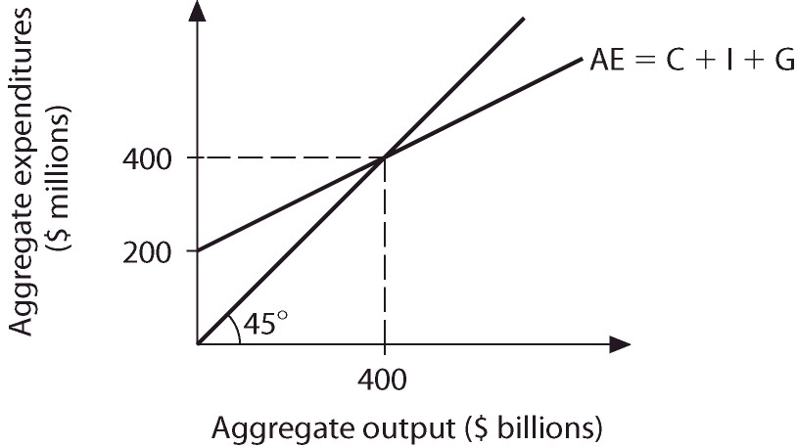

Figure 9.3

28)

Refer to Figure 9.3. At equilibrium, autonomous planned expenditures equal $________ billion.

A)

200

B)

100

C)

150

D)

300

Answer:

A

Diff: 2

Skill: A

29)

Refer to Figure 9.3. The expenditure multiplier is

A)

4.

B)

3.

C)

2.

D)

10.

Answer:

C

Diff: 2

Skill: A

30)

Refer to Figure 9.3. If autonomous planned expenditure increases by $10 billion, equilibrium aggregate output ________ to $________ billion.

A)

decreases; 360

B)

increases; 550

C)

increases; 420

D)

increases; 440

Answer:

C

Diff: 2

Skill: A

Refer to the information provided in Figure 9.4 below to answer the questions that follow.

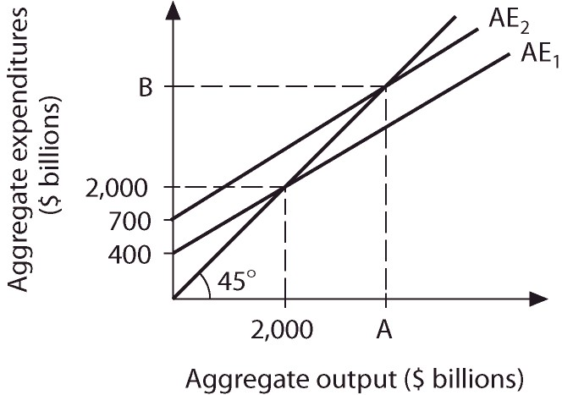

Figure 9.4

31)

Refer to Figure 9.4. Along aggregate expenditure AE1, the MPC is

A)

.6.

B)

.7.

C)

.8.

D)

.9.

Answer:

C

Diff: 2

Skill: A

32)

Refer to Figure 9.4. What is the value of Point A?

A)

$3,500 billion.

B)

$6,000 billion.

C)

$7,000 billion.

D)

Cannot be determined from the given information.

Answer:

A

Diff: 3

Skill: A

33)

Refer to Figure 9.4. What is the value of Point B?

A)

$7,000 billion

B)

$3,500 billion

C)

$6,000 billion

D)

Cannot be determined from the given information.

Answer:

B

Diff: 3

Skill: A

34)

Refer to Figure 9.4. What is the value of the expenditure multiplier?

A)

8

B)

10

C)

5

D)

20

Answer:

C

Diff: 2

Skill: A

35)

Refer to Figure 9.4. Along AE1, injections equal leakages when aggregate output equals $________ billion.

A)

1,500

B)

3,000

C)

2,500

D)

2,000

Answer:

D

Diff: 2

Skill: A

36)

Refer to Figure 9.4. If aggregate expenditures are represented by AE2 and government spending increases by $20 billion, equilibrium aggregate output increases by $________ billion.

A)

100

B)

200

C)

400

D)

800

Answer:

A

Diff: 2

Skill: A

37)

Government spending increases by $50 billion and the equilibrium level of output increases by $200 billion. The government spending multiplier

A)

is 5.

B)

is 4.

C)

cannot be determined from this information, because the MPC is not given.

D)

is 6.

Answer:

B

Diff: 2

Skill: A

38)

Assume an economy is in equilibrium at an output level of $1,000 billion. If government spending increases by $100 billion, then at the output level of $1,000 billion, there is

A)

an unplanned rise in inventories.

B)

an unplanned fall in inventories.

C)

an unplanned inventory change of zero.

D)

either an unplanned increase or decrease in inventories depending on the value of the MPC.

Answer:

B

Diff: 2

Skill: A

39)

Assume an economy is in equilibrium at an output level of $400 billion. If government purchases decrease by $50 billion, then at the output level of $400 billion, there is

A)

an unplanned increase in inventories.

B)

an unplanned inventory change of zero.

C)

either an unplanned increase or decrease in inventories depending on the value of the MPC.

D)

an unplanned decrease in inventories.

Answer:

A

Diff: 2

Skill: A

40)

A decrease in lump-sum taxes will

A)

make the consumption function flatter.

B)

make the consumption function steeper.

C)

shift the consumption function downward.

D)

shift the consumption function upward.

Answer:

D

Diff: 2

Skill: C

41)

The tax multiplier is

A)

the ratio of the change in taxes to the change in the equilibrium level of output.

B)

the MPC multiplied by the MPS.

C)

the difference in taxes multiplied by the change in the equilibrium level of output.

D)

the ratio of the change in the equilibrium level of output to the change in taxes.

Answer:

D

Diff: 1

Skill: D

42)

The formula for the tax multiplier is

A)

-(MPS/MPC).

B)

MPS/MPC.

C)

-(MPC/MPS).

D)

-1/MPS.

Answer:

C

Diff: 1

Skill: D

43)

If the MPC is .9, the tax multiplier is

A)

-9.

B)

-10.

C)

-1.10.

D)

10.

Answer:

A

Diff: 1

Skill: F

44)

If the MPC is .55, the tax multiplier is

A)

-2.22.

B)

-1.22.

C)

-2.33.

D)

-3.33.

Answer:

B

Diff: 1

Skill: F

45)

If the MPS is .3, the tax multiplier is

A)

-2.5.

B)

-1.67.

C)

-1.5.

D)

-2.33.

Answer:

D

Diff: 1

Skill: F

46)

If the MPS is .25, the tax multiplier is

A)

-9.

B)

-4.

C)

-3.

D)

-5.

Answer:

C

Diff: 1

Skill: F

47)

Taxes are reduced by $50 billion and income increases by $200 billion. The value of the tax multiplier is

A)

-4.

B)

-20.

C)

-10.

D)

-5.

Answer:

A

Diff: 2

Skill: A

48)

Taxes are reduced by $100 billion and income increases by $1,000 billion. The value of the tax multiplier is

A)

-4.

B)

9.

C)

-10.

D)

-5.

Answer:

C

Diff: 2

Skill: A

49)

If the tax multiplier is -6 and taxes are reduced by $100 billion, output

A)

falls by $100 billion.

B)

falls by $600 billion.

C)

increases by $600 billion.

D)

increases by $100 billion.

Answer:

C

Diff: 2

Skill: A

50)

If the tax multiplier is -5 and taxes are increased by $10 billion, output

A)

falls by $10 billion.

B)

falls by $50 billion.

C)

increases by $500 billion.

D)

increases by $50 billion.

Answer:

B

Diff: 2

Skill: A

Refer to the information provided in Figure 9.5 below to answer the questions that follow.

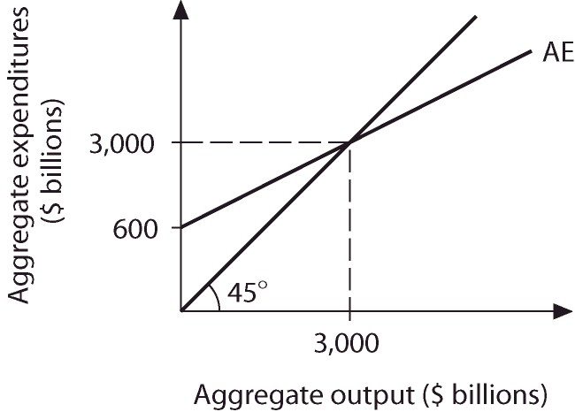

Figure 9.5

51)

Refer to Figure 9.5. Which of the following equations best represents the aggregate expenditure function?

A)

AE = 600 + .5Y.

B)

AE = 600+ .8Y.

C)

AE = 750 + .75Y.

D)

AE = 2,250 + .2Y.

Answer:

B

Diff: 3

Skill: A

52)

Refer to Figure 9.5. At aggregate output of $4,000 billion, unplanned inventories equal $________ billion.

A)

200

B)

250

C)

-250

D)

-1,000

Answer:

A

Diff: 3

Skill: A

53)

Refer to Figure 9.5. The government spending multiplier equals ________ and the tax multiplier equals ________.

A)

2.5; -1.5

B)

4; -3

C)

5; -4

D)

9; -8

Answer:

C

Diff: 2

Skill: A

54)

Refer to Figure 9.5. If the economy is in equilibrium and the government increases spending by $100 billion, equilibrium aggregate expenditures increase to $________ billion.

A)

3,400

B)

3,100

C)

3,500

D)

3,600

Answer:

C

Diff: 2

Skill: A

55)

Refer to Figure 9.5. If the economy is in equilibrium and the government decreases spending by $200 billion, equilibrium aggregate output decreases to $________ billion.

A)

2,800

B)

2,400

C)

2,200

D)

2,000

Answer:

D

Diff: 2

Skill: A

56)

Refer to Figure 9.5. If the economy is in equilibrium and the government increases taxes by $50 billion, equilibrium aggregate output ________ to $________ billion.

A)

increases; 3,050

B)

decreases; 2,950

C)

decreases; 2,800

D)

decreases; 2,850

Answer:

C

Diff: 2

Skill: A

57)

Refer to Figure 9.5. If the economy is in equilibrium and the government increases spending by $100 billion and increases taxes by $100 billion, equilibrium aggregate output

A)

does not change.

B)

increases by $100 billion.

C)

increases by less than $100 billion.

D)

increases by more than $100 billion.

Answer:

B

Diff: 2

Skill: A

58)

If the government spending multiplier is 10, then the tax multiplier

A)

is -5.

B)

is -4.

C)

is -9.

D)

cannot be determined because the MPS is not given.

Answer:

C

Diff: 2

Skill: F

59)

If the tax multiplier is -6.66, then the government purchases multiplier

A)

is 6.66.

B)

is 7.66.

C)

is 3.34.

D)

cannot be determined because the MPS is not given.

Answer:

B

Diff: 2

Skill: F

60)

If government spending is increased by $400, taxes are reduced by $400, and the MPS is .5, equilibrium output will change by

A)

-$400.

B)

$0.

C)

$1,200.

D)

an amount that cannot be determined from this information.

Answer:

C

Diff: 2

Skill: A

61)

If government purchases are increased by $100, taxes are reduced by $100, and the MPC is .8, equilibrium output will change by

A)

-$400.

B)

$1,800.

C)

$900.

D)

an amount that cannot be determined from this information.

Answer:

C

Diff: 2

Skill: A

62)

If government spending is increased by $700 and taxes are increased by $700, the equilibrium level of income will

A)

decrease by $700.

B)

not change.

C)

increase by $700.

D)

increase by $1,400.

Answer:

C

Diff: 2

Skill: A

63)

If government purchases are decreased by $800 and taxes are decreased by $800, the equilibrium level of income will

A)

decrease by $800.

B)

increase by $800.

C)

not change.

D)

decrease by $1600

Answer:

A

Diff: 2

Skill: A

64)

Assume that the MPC is .75. If government spending increases by $400, equilibrium output ________; and if taxes increase by $400, equilibrium output ________.

A)

increases by $1,600; decreases by $1,600

B)

increases by $1,600; decreases by $1,200

C)

increases by $1,200; decreases by $1,600

D)

increases by $400; decreases by $400

Answer:

B

Diff: 2

Skill: A

65)

Assume that the MPC is .9. If government purchases increase by $100, equilibrium output ________; and if taxes increase by $100, equilibrium output ________.

A)

increases by $1,000; decreases by $1,000

B)

increases by $900; decreases by $1,000

C)

increases by $1,000; decreases by $900

D)

increases by $400; decreases by $400

Answer:

C

Diff: 2

Skill: A

66)

You are hired by the Council of Economic Advisors (CEA) as an economic consultant. The Chairperson of the CEA tells you that she believes the current unemployment rate is too high. The unemployment rate can be reduced if aggregate output increases. She wants to know what policy to pursue to increase aggregate output by $300 billion. The best estimate she has for the MPC is .8. Which of the following policies should you recommend?

A)

Increase government purchases by $60 billion.

B)

Increase government purchases by $150 billion.

C)

Cut taxes by $60 billion.

D)

Cut taxes by $60 billion and to increase government purchases by $60 billion.

Answer:

A

Diff: 2

Skill: A

67)

You are hired by the Bureau of Economic Analogies (BEA) as an economic consultant. The Chairperson of the BEA tells you that he believes the current unemployment rate is too low. The unemployment rate can be increased if aggregate output decreases. He wants to know what policy to pursue to decrease aggregate output by $100 billion. The best estimate he has for the MPC is .9. Which of the following policies should you recommend?

A)

Decrease government spending by $10 billion.

B)

Decrease government spending by $100 billion.

C)

Increase taxes by $100 billion.

D)

Cut taxes by $60 billion and to increase government spending by $60 billion.

Answer:

A

Diff: 2

Skill: A

68)

You are hired by the Council of Economic Advisors (CEA) as an economic consultant. The chairperson of the CEA tells you that she believes the current unemployment rate is too high. The unemployment rate can be reduced if aggregate output increases. She wants to know what policy to pursue to increase aggregate output by $300 billion. The best estimate she has for the MPC is .8. Which of the following policies should you recommend?

A)

Increase government purchases by $75 billion.

B)

Reduce taxes by $75 billion.

C)

Reduce taxes by $75 billion and to increase government purchases by $75 billion.

D)

Reduce the budget deficit by $300 billion.

Answer:

B

Diff: 2

Skill: A

69)

You are hired by the Bureau of Economic Analogies (BEA) as an economic consultant. The chairperson of the BEA tells you that he believes the current unemployment rate is too high. The unemployment rate can be reduced if aggregate output increases. He wants to know what policy to pursue to increase aggregate output by $500 billion. The best estimate he has for the MPC is .7. Which of the following policies should you recommend?

A)

Decrease government spending by $75 billion.

B)

Reduce taxes by $214.3 billion.

C)

Reduce taxes by $314.3 billion and to decrease government spending by $500 billion.

D)

Reduce the budget deficit by $300 billion.

Answer:

B

Diff: 2

Skill: A

70)

You are hired by the Council of Economic Advisors (CEA) as an economic consultant. The chairperson of the CEA tells you that she believes the current unemployment rate is too high. The unemployment rate can be reduced if aggregate output increases. She wants to know what policy to pursue to increase aggregate output by $300 billion. The best estimate he has for the MPC is .8. Which of the following policies should you recommend?

A)

Increase government spending by $300 billion and reduce taxes by $300 billion.

B)

Reduce government spending by $300 billion and increase taxes by $300 billion.

C)

Increase both government spending and taxes by $300 billion.

D)

Decrease both government spending and taxes by $300 billion.

Answer:

C

Diff: 2

Skill: A

71)

You are hired by the Bureau of Economic Analogies (BEA) as an economic consultant. The chairperson of the BEA tells you that he believes the current unemployment rate is too high. The unemployment rate can be reduced if aggregate output increases. He wants to know what policy to pursue to increase aggregate output by $300 billion. The best estimate he has for the MPC is .8. Which of the following policies should you recommend?

A)

Reduce government spending by $300 billion and reduce taxes by $300 billion.

B)

Increase both government spending and taxes by $300 billion.

C)

Increase government spending by $300 billion and reduce taxes by $300 billion.

D)

None of the above

Answer:

B

Diff: 2

Skill: A

72)

As the size of the MPC increases, the value of the balanced-budget multiplier

A)

increases.

B)

decreases.

C)

remains constant.

D)

could either increase or decrease.

Answer:

C

Diff: 2

Skill: F

73)

The balanced-budget multiplier

A)

equals 0.

B)

is greater than 0 but less than 1.

C)

is greater than 1.

D)

equals 1.

Answer:

D

Diff: 1

Skill: D

74)

Suppose that in the beginning of 2003 the federal debt was $4 trillion. During 2003, the government balanced its budget. At the end of 2003, the federal debt

A)

increased.

B)

stayed the same.

C)

decreased.

D)

was eliminated.

Answer:

B

Diff: 2

Skill: C

True/False

1)

As the MPC decreases, the government spending multiplier increases.

Answer:

True
False

Diff: 1

Skill: F

2)

If autonomous spending increases, the aggregate expenditure function becomes steeper.

Answer:

True
False

Diff: 1

Skill: F

3)

If the government increases taxes by $1 billion and increases spending by $1 billion, equilibrium output increases by $1 billion.

Answer:

True
False

Diff: 2

Skill: C

4)

A tax cut of $10 billion will have less effect on the economy than an increase in government purchases of $10 billion.

Answer:

True
False

Diff: 2

Skill: C

5)

The balanced-budget multiplier works whenever the government increases spending and increases taxes by the same amount.

Answer:

True
False

Diff: 1

Skill: C

9.3 The Federal Budget
Multiple Choice

1)

The total amount owed by the federal government to the public is the

A)

federal budget deficit.

B)

federal debt.

C)

net tax revenue.

D)

fiscal drag.

Answer:

B

Diff: 1

Skill: D

2)

What is the largest expenditure source in the government's budget?

A)

Consumption

B)

Transfer payments

C)

Net interest payments

D)

Net subsidies

Answer:

B

Diff: 1

Skill: F

3)

What is the largest source of revenue in the government's budget?

A)

Social insurance

B)

Indirect business taxes

C)

Corporate taxes

D)

Personal taxes

Answer:

D

Diff: 1

Skill: F

4)

A government's debt is reduced when it

A)

balances is budget.

B)

sells more bonds.

C)

runs a deficit.

D)

runs a surplus.

Answer:

D

Diff: 2

Skill: F

5)

When a government runs a deficit

A)

its debt increases.

B)

it must raise taxes

C)

its debt decreases.

D)

it must cut spending.

Answer:

A

Diff: 1

Skill: C

True/False

1)

The amount the government owes to the public is the deficit.

Answer:

True
False

Diff: 1

Skill: D

2)

If tax receipts are less than government expenditures the government is running a deficit.

Answer:

True
False

Diff: 1

Skill: F

3)

If the government runs a deficit, then the government debt increases.

Answer:

True
False

Diff: 2

Skill: C

4)

defense spending is the largest part of the U.S. government spending.

Answer:

True
False

Diff: 2

Skill: F

5)

The government budget is balanced when tax receipts equal government spending.

Answer:

True
False

Diff: 1

Skill: C

9.4 The Economy’s Influence on Government Budget
Multiple Choice

1)

Which of the following is a CORRECT sequence of events during a recession?

A)

Unemployment falls, income falls, tax revenue falls, unemployment benefits rise, and the budget deficit rises.

B)

Unemployment rises, income falls, tax revenue falls, unemployment benefits rise, and the budget deficit rises.

C)

Unemployment rises, income falls, tax revenue rises, unemployment benefits fall, and the budget deficit falls.

D)

Unemployment rises, income rises, tax revenue rises, unemployment benefits rise, and the budget deficit rises.

Answer:

B

Diff: 2

Skill: A

2)

Which of the following is a CORRECT sequence of events during an expansion?

A)

Unemployment falls, income falls, tax revenue falls, unemployment benefits rise, and the budget deficit falls.

B)

Unemployment rises, income falls, tax revenue falls, unemployment benefits rise, and the budget deficit rises.

C)

Unemployment rises, income falls, tax revenue rises, unemployment benefits fall, and the budget deficit falls.

D)

Unemployment falls, income rises, tax revenue rises, unemployment benefits fall, and the budget deficit falls.

Answer:

D

Diff: 2

Skill: A

3)

The presence of automatic stabilizers means that the federal deficit is ________ than it otherwise would be in a recession and ________ than it otherwise would be in an expansion.

A)

larger; smaller

B)

smaller; larger

C)

smaller; smaller

D)

larger; larger

Answer:

A

Diff: 2

Skill: C

4)

During a recession, automatic stabilizers cause the federal deficit to

A)

decrease.

B)

either increase or decrease.

C)

remain unchanged.

D)

increase.

Answer:

D

Diff: 2

Skill: C

5)

An example of an automatic stabilizer is

A)

the food stamp program.

B)

changing the tax laws to increase the marginal tax rates.

C)

the indexation of social security benefits to the consumer price index.

D)

the interest the government pays on loans.

Answer:

A

Diff: 2

Skill: F

6)

If the economy is in a recession, the full-employment deficit is ________ the actual deficit.

A)

larger than

B)

equal to

C)

smaller than

D)

equal to or larger than

Answer:

C

Diff: 1

Skill: C

7)

If the economy's full-employment output is $9 trillion, actual output is $8.5 trillion, and the budget deficit is $50 billion, the deficit in this case is known as a

A)

natural employment deficit.

B)

cyclical deficit.

C)

structural deficit.

D)

debt deficit.

Answer:

B

Diff: 1

Skill: C

8)

If the economy's full-employment output is $9 trillion, actual output is $9 trillion, and the budget deficit is $20 billion, the deficit in this case is known as a

A)

natural employment deficit.

B)

cyclical deficit.

C)

structural deficit.

D)

fiscal deficit.

Answer:

C

Diff: 1

Skill: C

9)

Assume that in the United States the actual deficit is $300 billion. If the United States were at full employment, the deficit would be $100 billion. The structural deficit in the United States is

A)

$100 billion.

B)

$200 billion.

C)

$300 billion.

D)

$400 billion.

Answer:

A

Diff: 1

Skill: C

10)

Assume that in the Atlantis the actual deficit is $200 billion. If the Atlantis were at full employment, the deficit would be $50 billion. The structural deficit in the Atlantis is

A)

$100 billion.

B)

$200 billion.

C)

$50 billion.

D)

$150 billion.

Answer:

C

Diff: 1

Skill: C

11)

If the economy is in a recession and the government lowers the tax rate, tax revenue

A)

will definitely increase.

B)

will definitely decrease.

C)

may increase, decrease or stay the same.

D)

will not change.

Answer:

C

Diff: 1

Skill: C

12)

In which case will the government collect more tax revenue?

A)

40% tax rate and $40,000 average income

B)

90% tax rate and $10,000 average income

C)

20% tax rate and $90,000 average income

D)

4% tax rate and $80,000 average income

Answer:

C

Diff: 1

Skill: A

13)

If taxes are a function of income, then the AE function is

A)

flatter than if taxes are a lump-sum amount.

B)

steeper than if taxes are a lump-sum amount.

C)

vertical.

D)

downward sloping.

Answer:

A

Diff: 2

Skill: F

True/False

1)

During recessions, automatic stabilizers work to reduce government expenditures and increase government revenues.

Answer:

True
False

Diff: 2

Skill: C

2)

The cyclical deficit of the full-employment budget is zero.

Answer:

True
False

Diff: 1

Skill: D

3)

The structural deficit is the deficit at full employment.

Answer:

True
False

Diff: 1

Skill: D

4)

In an expansion the U.S. federal government deficit automatically grows.

Answer:

True
False

Diff: 1

Skill: C

5)

Automatic stabilizers include those elements of government spending that automatically grow during a recession.

Answer:

True
False

Diff: 1

Skill: C

9.5 Appendix A
Multiple Choice

1)

Assume that taxes depend on income. The MPC is .8 and t is .25. The government spending multiplier is

A)

1.67.

B)

2.5.

C)

5.

D)

10.

Answer:

B

Diff: 2

Skill: F

2)

Assume that taxes depend on income. The MPC is .9 and t is .3. The government spending multiplier is

A)

10.

B)

2.7.

C)

1.17.

D)

1.42.

Answer:

B

Diff: 2

Skill: F

3)

Assume that taxes depend on income. The MPC is .5 and t is .2. If government spending increases by $10 billion, the equilibrium level of output will increase by

A)

$16.7 billion.

B)

$25 billion.

C)

$50 billion.

D)

$100 billion.

Answer:

A

Diff: 2

Skill: A

4)

Assume that taxes depend on income. The MPC is .8 and t is .4. If government purchases increase by $100 billion, the equilibrium level of output will increase by

A)

$16.7 billion.

B)

$215.9 billion.

C)

$57.5 billion.

D)

$192.31 billion.

Answer:

D

Diff: 2

Skill: A

5)

If taxes depend on income and the MPC is .8 and t is .5, the tax multiplier is

A)

-1.6.

B)

-1.3.

C)

75.

D)

67.

Answer:

B

Diff: 1

Skill: A

6)

Assume that taxes depend on income and the MPC is .8 and t is .5. An increase in taxes of $10 billion will decrease equilibrium income by

A)

$16 billion.

B)

$13.3 billion.

C)

$7.5 billion.

D)

$6.7 billion.

Answer:

B

Diff: 2

Skill: A

7)

If taxes depend on income, then the magnitude of the government spending multiplier ________ it would be if taxes were a lump-sum amount.

A)

could be either larger than or smaller than

B)

is larger than

C)

is equal to what

D)

is smaller than

Answer:

D

Diff: 2

Skill: C

8)

If taxes depend on income, then the absolute value of the tax multiplier ________ it would be if taxes were a lump-sum amount.

A)

could be either larger than or smaller than

B)

is larger than

C)

is equal to what

D)

is smaller than

Answer:

D

Diff: 2

Skill: C

9)

As the tax rate increases, the government spending multiplier

A)

increases.

B)

decreases.

C)

does not change.

D)

could either increase or decrease depending on the value of the MPC.

Answer:

B

Diff: 1

Skill: F

10)

As the tax rate increases, the absolute value of the tax multiplier

A)

increases.

B)

decreases.

C)

does not change.

D)

could either increase or decrease depending on the value of the MPC.

Answer:

B

Diff: 2

Skill: F

True/False

1)

When taxes depend on incomes, a higher tax rate implies a higher government spending multiplier.

Answer:

True
False

Diff: 1

Skill: F

2)

When the MPC is .9 and t is .3, then the government spending multiplier is about -2.4.

Answer:

True
False

Diff: 2

Skill: F

3)

If the MPS is .2 and t is .3, then the tax multiplier is about -3.8.

Answer:

True
False

Diff: 3

Skill: C

4)

If the MPS is .4 and t is .3, then the tax multiplier is about -1.03.

Answer:

True
False

Diff: 3

Skill: C

5)

When the tax rate increases, the absolute value of the tax multiplier falls.

Answer:

True
False

Diff: 1

Skill: F

